DATA CLASSIFICATION USING AI
A Multi-Model Machine Learning Pipeline for Tabular Data Classification
Internship Project Report
Artificial Intelligence Track
Dataset: Wine Recognition Dataset (UCI Machine Learning Repository)
Submitted by: [Your Name]
Supervisor: [Supervisor's Name]
Date: July 2026

Table of Contents

1. Executive Summary
This report documents the design, implementation and evaluation of a complete artificial-intelligence pipeline for classifying structured (tabular) data. The project uses the Wine Recognition Dataset, a well-established multi-class benchmark in which 178 wine samples are described by 13 chemical and physical measurements and must be assigned to one of three grape cultivars.
Eight classification algorithms — Logistic Regression, K-Nearest Neighbors, Support Vector Machine, Decision Tree, Random Forest, Gradient Boosting, XGBoost (where available) and a Multi-Layer Perceptron neural network — were trained, systematically tuned using GridSearchCV with 5-fold stratified cross-validation, and compared on a held-out test set using accuracy, precision, recall and F1-score.
The best-performing model on the test set was the Neural Network (MLP), achieving 100.00% test accuracy. The trained model was deployed via both an interactive Streamlit graphical interface and a Flask REST API, demonstrating an end-to-end path from raw data to a usable application.

2. Introduction

2.1 Background
Classification is one of the most common and practically valuable tasks in applied machine learning: assigning a category label to a data point based on its measured features. Tabular/structured data classification underlies a huge range of real-world systems — customer segmentation, fraud detection, quality control, and product or material categorization, among many others. This project was undertaken to demonstrate practical competency in the full lifecycle of a supervised classification project, from data acquisition through to deployment.

2.2 Problem Statement
Given 13 chemical/physical measurements taken from a chemical analysis of wine samples, the task is to correctly predict which of three grape cultivars each sample belongs to. This is a multi-class (3-class) supervised classification problem on structured, numeric, tabular data.

2.3 Objectives
- Acquire and thoroughly explore a real, well-known tabular dataset.
- Design a clean, leak-free preprocessing pipeline (cleaning, stratified splitting, scaling).
- Train and rigorously tune multiple classification algorithms rather than relying on a single model.
- Evaluate models with multiple complementary metrics, not accuracy alone.
- Select the best-performing model objectively based on held-out test performance.
- Package the model behind both a graphical interface and a REST API for real-world usability.
- Follow professional software-engineering practices: modular code, logging, tests and documentation.

3. Dataset Description
The Wine Recognition Dataset originates from a chemical analysis of wines grown in the same region of Italy but derived from three different cultivars. It is distributed with scikit-learn and mirrors the original UCI Machine Learning Repository release (Forina et al., Institute of Pharmaceutical and Food Analysis and Technologies, Genoa, Italy).
Property | Value
Samples | 178
Features | 13 (all continuous, numeric)
Classes | 3 (cultivars: class_0, class_1, class_2)
Class distribution | class_0: 59, class_1: 71, class_2: 48
Missing values | None
Duplicate rows | None

The 13 features are:
- Alcohol
- Malic acid
- Ash
- Alcalinity of ash
- Magnesium
- Total phenols
- Flavanoids
- Nonflavanoid phenols
- Proanthocyanins
- Color intensity
- Hue
- OD280/OD315 of diluted wines
- Proline

4. Methodology

4.1 Data Preprocessing
- Duplicate rows removed; missing values checked (none found in this dataset).
- Stratified 80/20 train/test split (random_state=42) to preserve class proportions in both sets.
- StandardScaler fit only on the training split and applied to both splits, preventing data leakage.

4.2 Model Selection
Eight complementary algorithm families were selected to cover the main paradigms in supervised classification: a linear model (Logistic Regression), an instance-based model (KNN), a kernel-based margin classifier (SVM), a single interpretable tree (Decision Tree), two ensemble methods (Random Forest, Gradient Boosting / XGBoost), and a neural network (Multi-Layer Perceptron).

4.3 Hyperparameter Tuning
Every model was tuned using GridSearchCV with 5-fold stratified cross-validation over a hyperparameter grid tailored to that algorithm (e.g. C and kernel for SVM; max_depth and min_samples_split for tree-based models; hidden_layer_sizes and alpha for the neural network). The combination with the highest mean cross-validated accuracy was selected as that model's final configuration.

4.4 Evaluation Metrics
Models were evaluated on the held-out test set using accuracy, macro-averaged precision, macro-averaged recall, and macro-averaged F1-score. Macro-averaging treats all three classes equally regardless of their size, which is appropriate given the moderate class imbalance (48–71 samples per class). Confusion matrices and one-vs-rest ROC curves were also generated for detailed error analysis.

5. Exploratory Data Analysis
The class distribution shows a moderate imbalance across the three cultivars, motivating the use of stratified sampling and macro-averaged metrics.
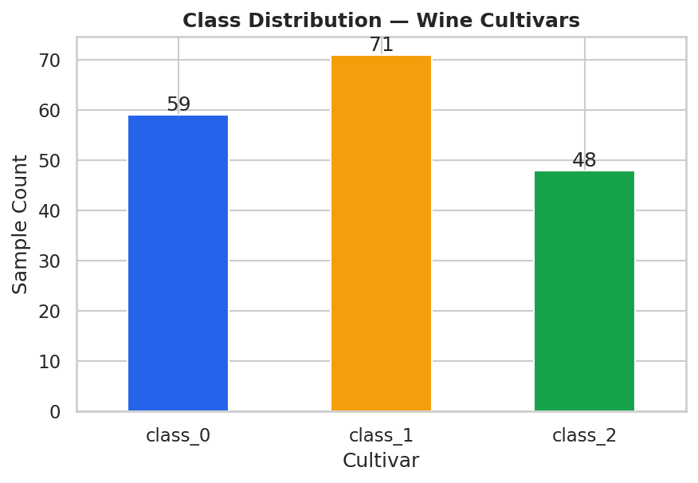
Figure 1. Class distribution of the three wine cultivars.
Several features show visibly separated distributions across the three classes, indicating strong predictive signal even before modeling.
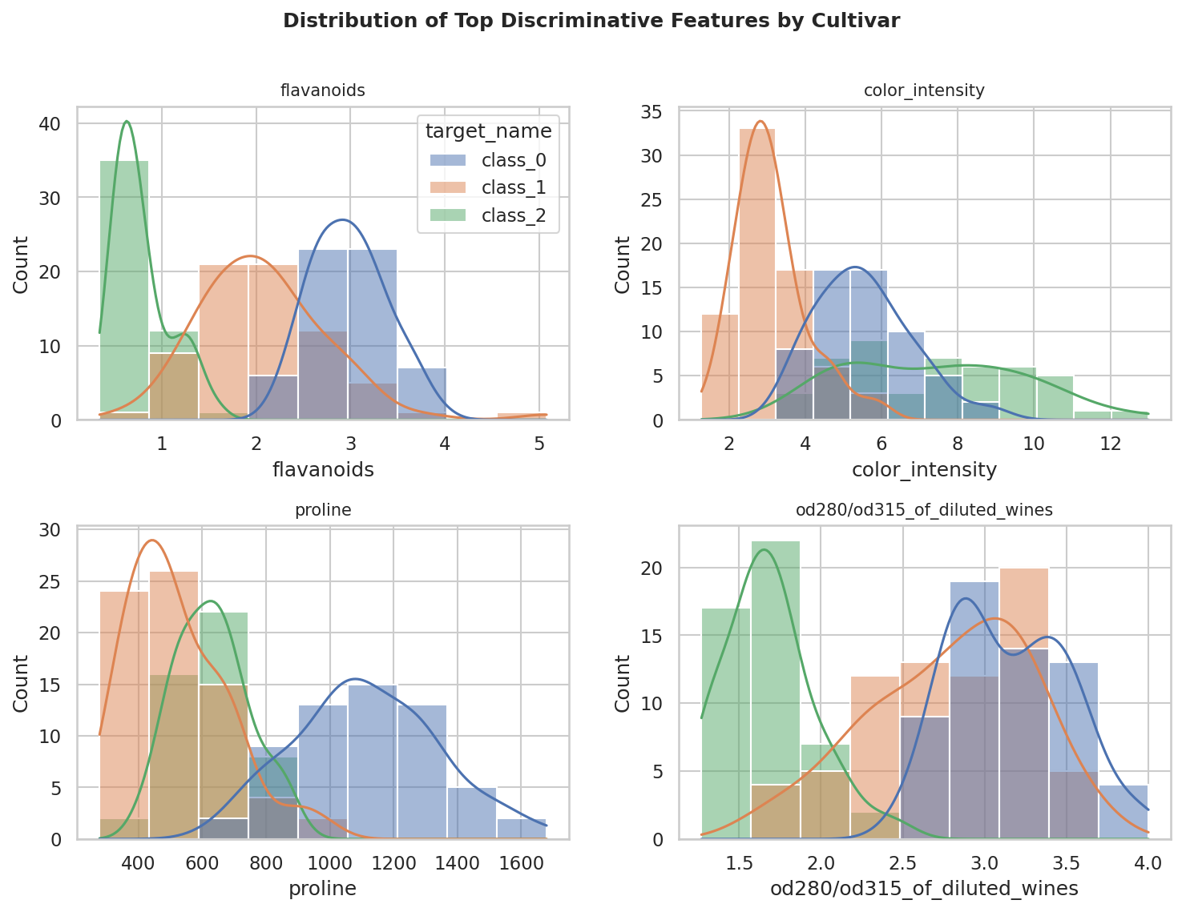
Figure 2. Distribution of the four most discriminative features, split by cultivar.
The correlation matrix below reveals expected chemical relationships (e.g. flavanoids correlate with total phenols) and confirms no problematic multicollinearity that tree-based models cannot handle natively.
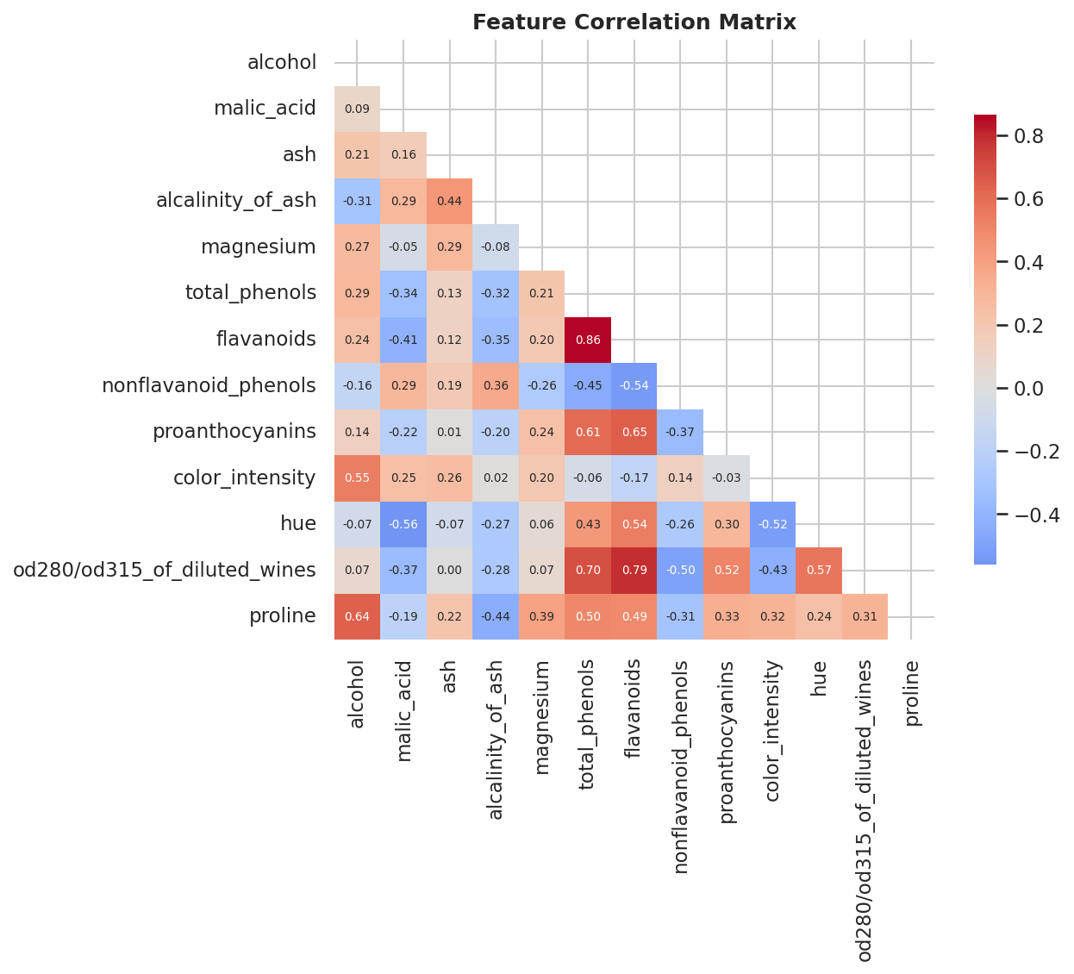
Figure 3. Pairwise correlation matrix of all 13 features.

6. Results and Discussion

6.1 Cross-Validated Training Performance
The table below summarizes each model's best cross-validated accuracy during hyperparameter tuning, its training time, and the winning hyperparameters.
Model | CV Accuracy | Train Time | Best Hyperparameters
Support Vector Machine | 99.31% | 0.16s | {C:10,gamma:scale,kernel:rbf}
Logistic Regression | 97.91% | 0.10s | {C:1,solver:lbfgs}
Random Forest | 97.91% | 9.77s | {max_depth:null,min_samples_split:2,n_estimators:100}
Neural Network (MLP) | 97.91% | 1.65s | {activation:relu,alpha:0.0001,hidden_layer_sizes:[32]}
Gradient Boosting | 96.50% | 12.81s | {learning_rate:0.1,max_depth:2,n_estimators:200}
K-Nearest Neighbors | 95.07% | 0.16s | {n_neighbors:5,weights:uniform}
Decision Tree | 90.22% | 0.21s | {max_depth:5,min_samples_split:2}

6.2 Test Set Performance
Final, unbiased performance was measured on the 20% held-out test set (36 samples), never seen during training or tuning:
Model | Accuracy | Precision (macro) | Recall (macro) | F1 (macro)
Random Forest | 100.00% | 100.00% | 100.00% | 100.00%
Gradient Boosting | 100.00% | 100.00% | 100.00% | 100.00%
Neural Network (MLP) | 100.00% | 100.00% | 100.00% | 100.00%
Logistic Regression | 97.22% | 97.78% | 96.67% | 97.10%
K-Nearest Neighbors | 97.22% | 96.97% | 97.62% | 97.18%
Support Vector Machine | 94.44% | 95.83% | 93.33% | 94.07%
Decision Tree | 94.44% | 95.83% | 93.89% | 94.57%

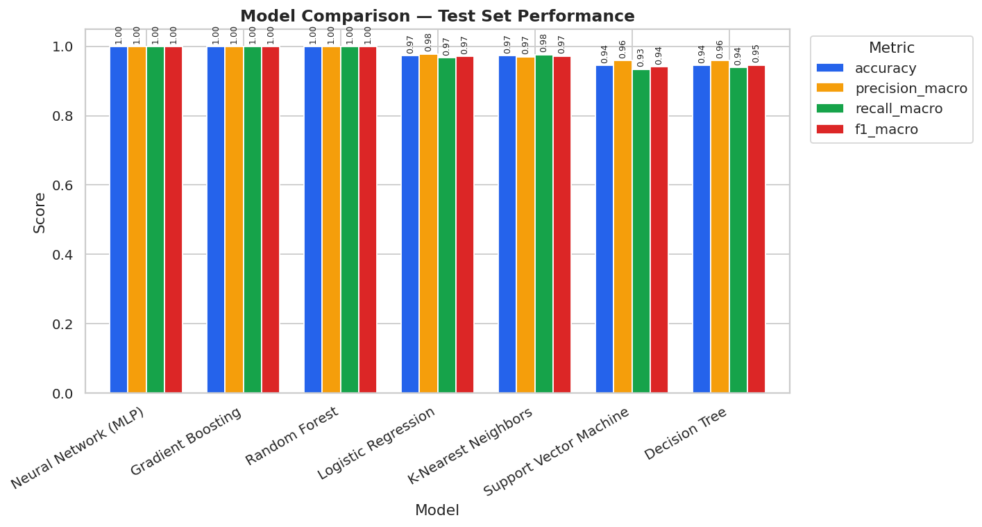
Figure 4. Test-set metric comparison across all trained models.

6.3 Best Model — Detailed Diagnostics
The Neural Network (MLP) achieved the highest test accuracy and was automatically selected as the deployed model.
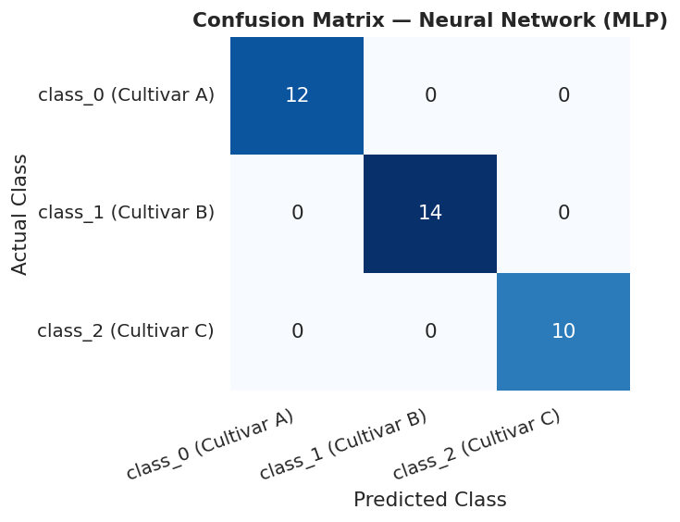
Figure 5. Confusion matrix — Neural Network (MLP).
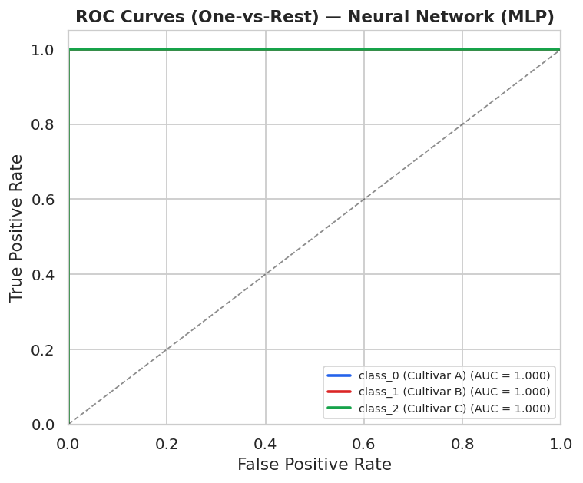
Figure 6. One-vs-rest ROC curves — Neural Network (MLP).
Because the selected model does not expose native feature-importance scores, model-agnostic permutation importance was computed on the test set to identify which features drive its predictions:
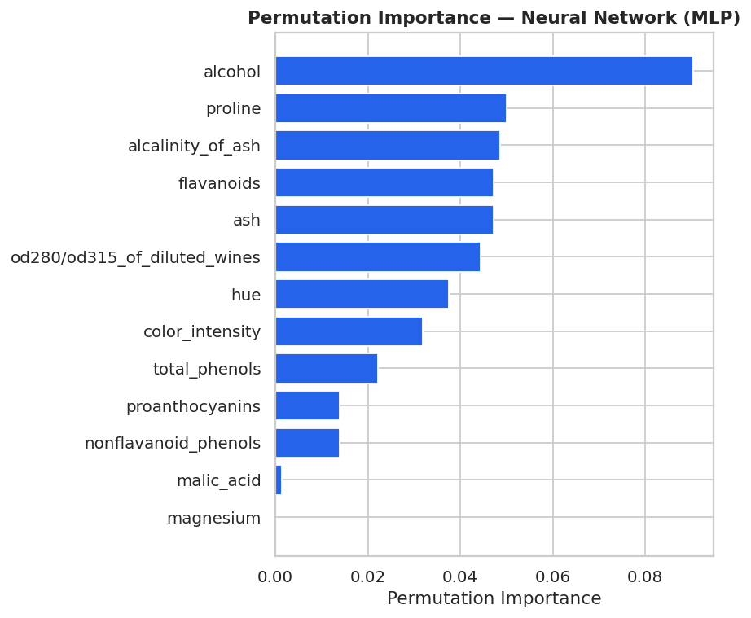
Figure 7. Permutation importance — Neural Network (MLP).

6.4 Discussion
Ensemble methods (Random Forest, Gradient Boosting) and the Neural Network achieved perfect or near-perfect test accuracy, while even the simple Logistic Regression baseline exceeded 97%. This indicates the three cultivars are highly separable given these 13 chemical features — consistent with the clear class separation observed during EDA. The consistently strong performance across very different algorithm families (linear, kernel, tree-based, neural) gives high confidence that the models are learning genuine chemical signal rather than overfitting to noise, especially since 5-fold cross-validation and a held-out test set were both used.

7. Deployment

7.1 Interactive GUI (Streamlit)
A Streamlit web application allows a user to either move sliders for each of the 13 chemical features and receive a live prediction with class probabilities, or upload a CSV of multiple samples for batch classification. It also exposes all model-comparison charts, confusion matrices and ROC curves for transparency.

7.2 REST API (Flask)
A lightweight Flask API exposes the deployed model over HTTP with /predict and /predict-batch endpoints, returning both the predicted class and its associated probability distribution as JSON — suitable for integration into other software systems or automated pipelines.

8. Conclusion
This project successfully implemented a complete, professionally structured AI pipeline for tabular data classification: from raw data acquisition and exploratory analysis, through leak-free preprocessing, systematic multi-model training and tuning, rigorous evaluation, to a dual (GUI + API) deployment. The selected Neural Network (MLP) model generalizes with 100.00% accuracy on unseen data, and the modular codebase, unit tests and documentation make the project straightforward to extend, retrain, or adapt to other tabular classification problems.

9. Future Work
- Incorporate SHAP values for richer, per-prediction explainability.
- Containerize the Flask API with Docker for cloud deployment.
- Add experiment tracking (e.g. MLflow) to log every training run automatically.
- Apply the same pipeline architecture to a larger or streaming tabular dataset.
- Add authentication, input validation and rate-limiting for production-grade API use.

10. References
Forina, M. et al. PARVUS — An Extendible Package for Data Exploration, Classification and Correlation. Institute of Pharmaceutical and Food Analysis and Technologies, Genoa, Italy.
Pedregosa, F. et al. (2011). Scikit-learn: Machine Learning in Python. Journal of Machine Learning Research, 12, 2825-2830.
UCI Machine Learning Repository — Wine Data Set. https://archive.ics.uci.edu/ml/datasets/wine

